**How to Create a VPC on AWS and SSH into Private EC2 Instances Using MobaXterm**

[[](https://medium.com/@taimoorhaiderx?source=post_page---byline--7b962d29d2d0---------------------------------------)](https://medium.com/@taimoorhaiderx?source=post_page---byline--7b962d29d2d0---------------------------------------)

[Taimoor Haider Ishtiaq](https://medium.com/@taimoorhaiderx?source=post_page---byline--7b962d29d2d0---------------------------------------)

·

Follow

6 min read

·

Mar 19, 2025

1

First, we will create a **VPC**, then set up **public and private subnets**. Next, we will assign **routing tables** (with an **Internet Gateway**) to the **public subnet**. Finally, we will create **EC2 instances** in both subnets and access them using **MobaXterm**.

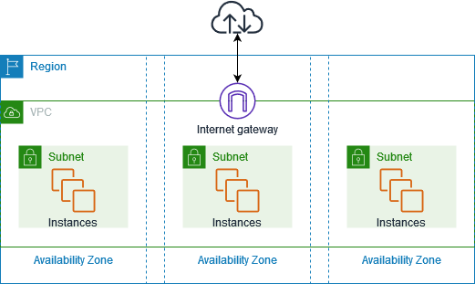

**1. Creating a VPC**

We will assign a **CIDR block** (e.g., **10.0.0.0/24**) to define the IP range for our **VPC**.

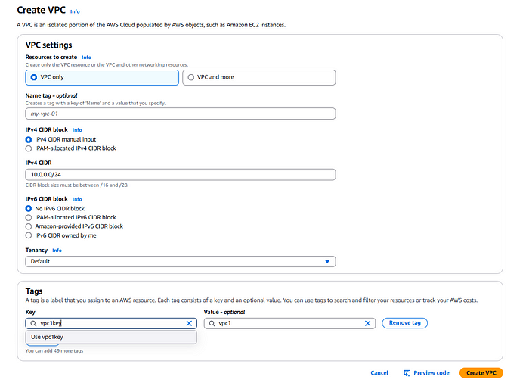

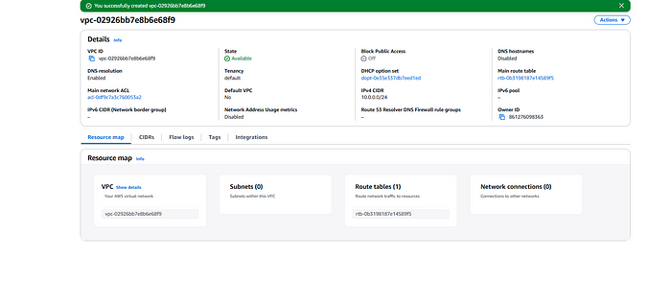

Now, we will perform **subnetting** on **10.0.0.0/24** (our **Parent Network**).

**Subnetting**

*Subnetting the****10.0.0.0/24****network involves dividing it into two smaller subnets by borrowing 1 additional bit from the host portion. The original****/24 subnet****has****256 IP addresses (10.0.0.0–10.0.0.255)****. By increasing the subnet mask to****/25****, we create****two equal subnets****, each with****128 IP addresses****. The first subnet is****10.0.0.0/25****(usable: 10.0.0.1–10.0.0.126, broadcast: 10.0.0.127), and the second is****10.0.0.128/25****(usable: 10.0.0.129–10.0.0.254, broadcast: 10.0.0.255). This process efficiently organizes IP allocation while maintaining logical separation.*

**1.1 Creating Subnet 1 (Public Subnet)**

Create subnets in differenct availibility zones.

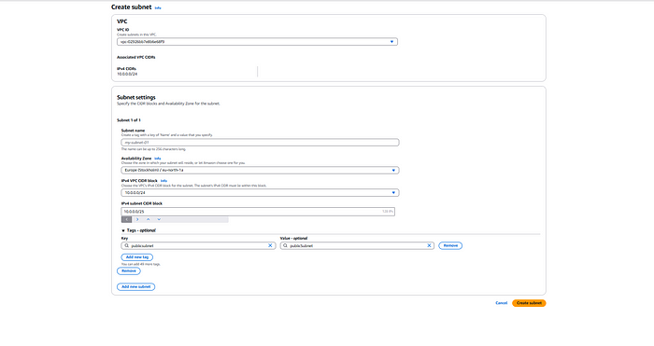

**1.2 Creating Subnet 2 (Private Subnet)**

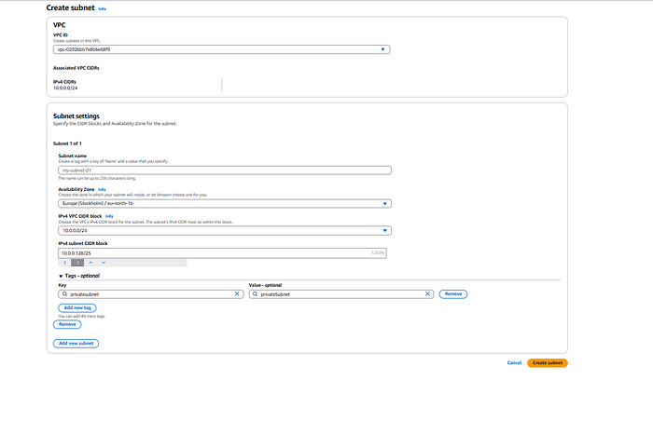

Our subnets are created.

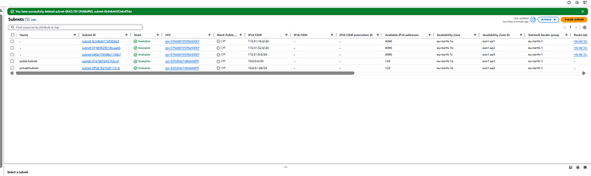

**2. Creating Routing Tables**

Routing tables define how network traffic is directed within the VPC. We will create and configure two routing tables:

* **Public Route Table:** This will be associated with the public subnet and will have a route pointing to the Internet Gateway, allowing instances in the public subnet to communicate with the internet.

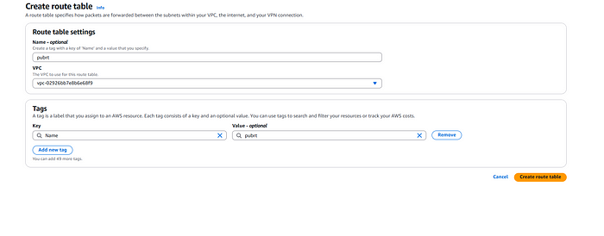

* **Private Route Table:** This will be associated with the private subnet, ensuring private instances do not have direct internet access.

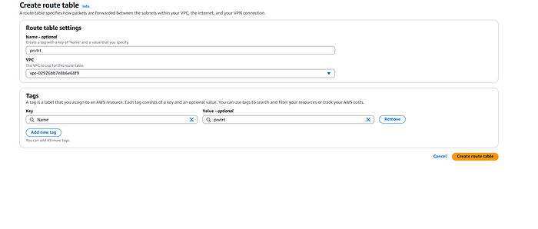

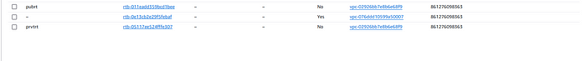

Associating the routing tables to the public and private subnets.

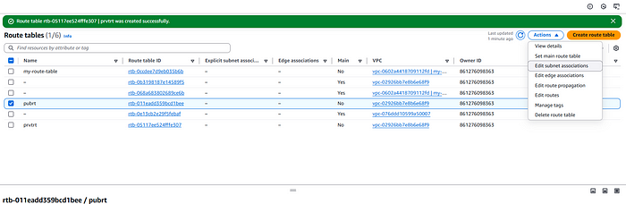

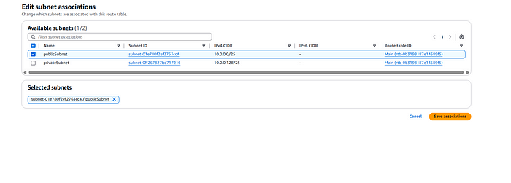

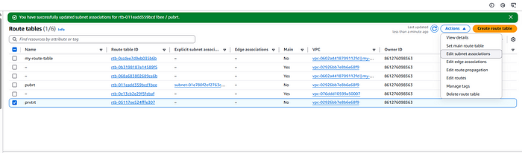

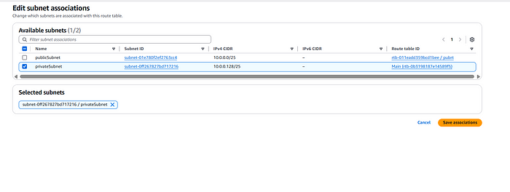

**3. Creating an Internet Gateway**

An **Internet Gateway (IGW)** allows instances in the public subnet to access the internet while enabling inbound traffic from external sources. In this step, we will:

* Create an **Internet Gateway** in AWS.
* Attach the **Internet Gateway** to the VPC.
* Update the **Public Route Table** to direct internet-bound traffic (0.0.0.0/0) through the Internet Gateway.

This ensures that instances in the **public subnet** can access the internet, enabling software updates, external API calls, and SSH connections.

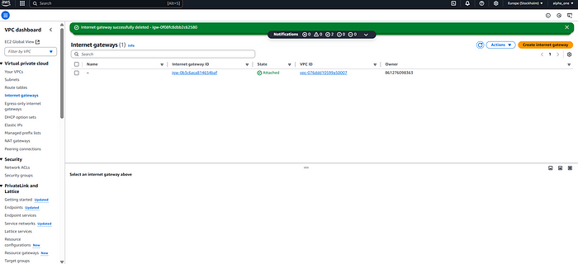

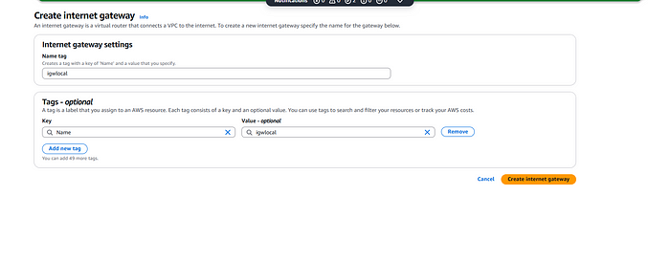

We have created the internet gateway (i.e igwlocal). e will attach this to our VPC.

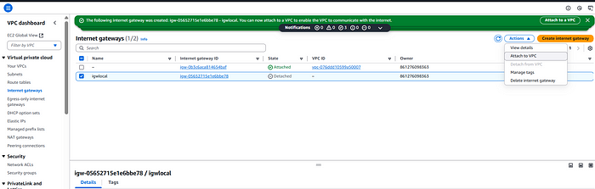

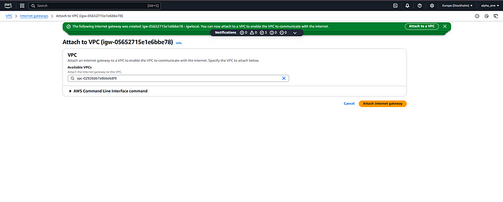

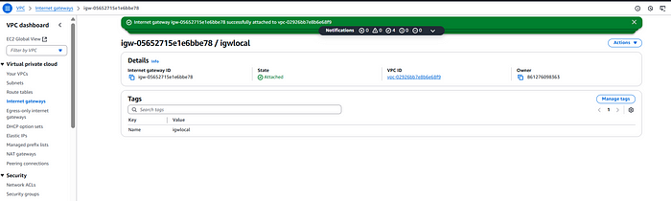

**4. Attaching the Internet Gateway to the Public Subnet**

While the **Internet Gateway (IGW)** is attached to the **VPC**, it does not automatically provide internet access to instances. We need to ensure that the public subnet can route traffic through it.

In this step, we will:

* Modify the **Public Route Table** to include a route for 0.0.0.0/0, directing traffic to the **Internet Gateway**.
* Associate the **Public Route Table** with the **Public Subnet**.

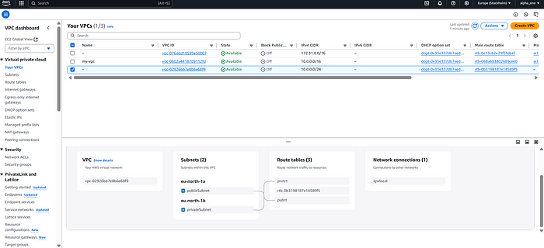

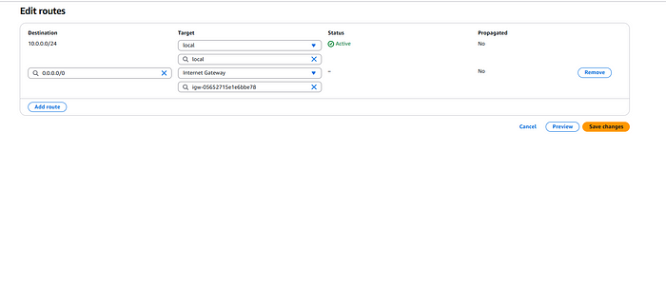

We can see in the Resource map of the VPC that the internet gateway is attached to the public subnet. This step ensures that instances in the **public subnet** can communicate with the internet while keeping the **private subnet** isolated.

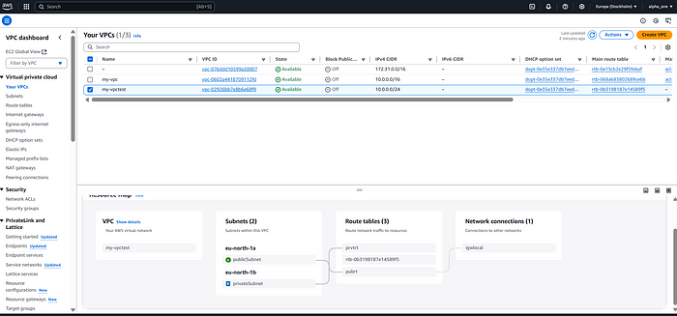

**5. Launching EC2 Instances in Public and Private Subnets**

Now, we will create two **EC2 instances**:

1. **Public Instance:** This instance will be launched in the **public subnet** and will have a **public IP address** assigned, allowing direct SSH access over the internet.

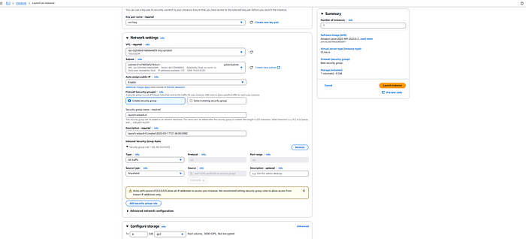

1. **Private Instance:** This instance will be launched in the **private subnet**, and we must **disable the public IP** to ensure it remains isolated from direct internet access.

The **public instance** will act as a **bastion host**, which we will later use to access the **private instance** securely.

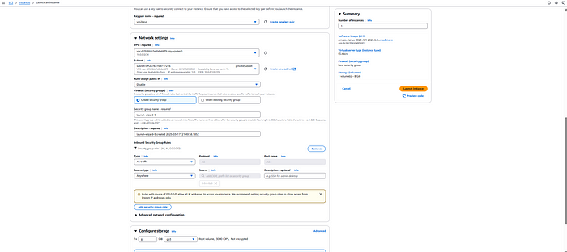

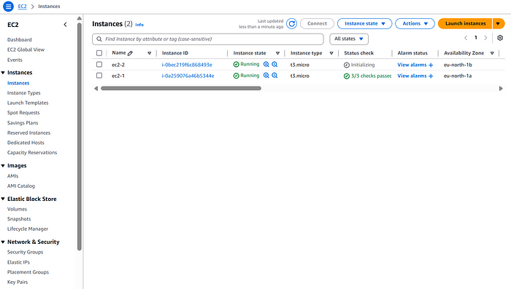

**6. Accessing the Public Instance Using MobaXterm**

Now, we will use **MobaXterm** to **SSH into the public EC2 instance** in the **public subnet**.

**What is MobaXterm?**

MobaXterm is a powerful **remote access tool** that provides an enhanced terminal for developers and system administrators. It supports **SSH, SFTP, RDP, and many other remote protocols**, making it ideal for managing cloud-based servers like AWS EC2 instances.

**Steps to SSH into the Public Instance using MobaXterm**

1. **Open MobaXterm** on your local machine.
2. Click on **“Session”** → Select **“SSH”**.
3. In the **“Remote Host”** field, enter the **public IP address** of your **public EC2 instance**.
4. Under **“Advanced SSH settings”**, browse and select your **.pem key file**.
5. Click **“OK”** to start the SSH session.

Once connected, we can **manage the public EC2 instance** directly from MobaXterm. Later, we will use this public instance to securely connect to the **private instance** inside the VPC.

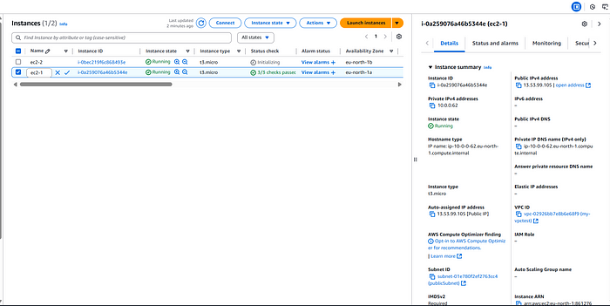

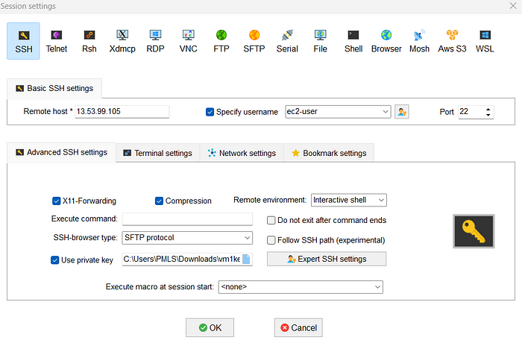

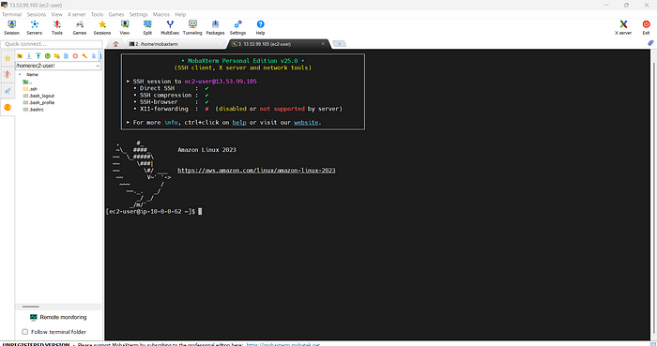

Now to jump to the instance in our private subnet we have to use the key pair that we created for private instance we have to follow these steps:-

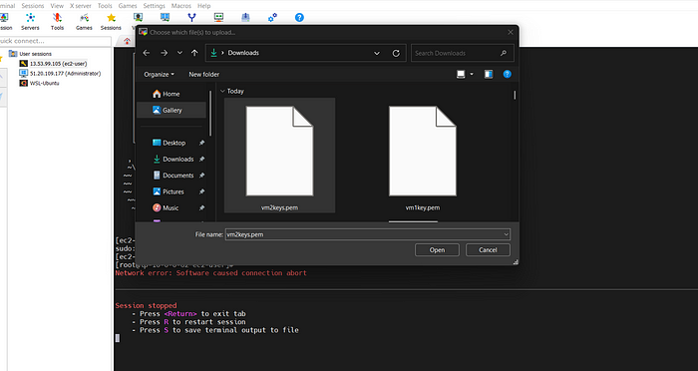

Upload the private virtual machine .pem file here.

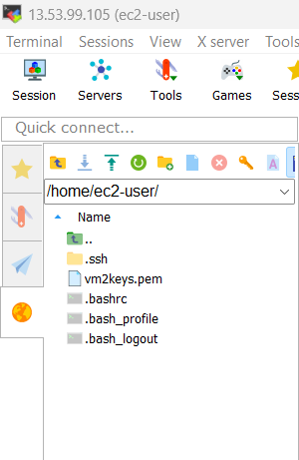

Giving permission using **chmod**command:-

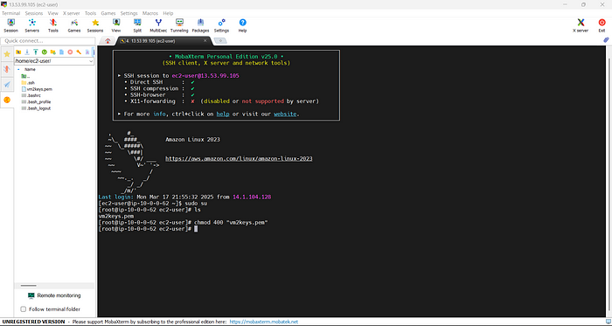

This is important because the private virtual machine does not have the public ip address so.You must **set the correct permissions** using chmod 400, or SSH will reject the key.

Now we use our private network private address to access it(ssh).

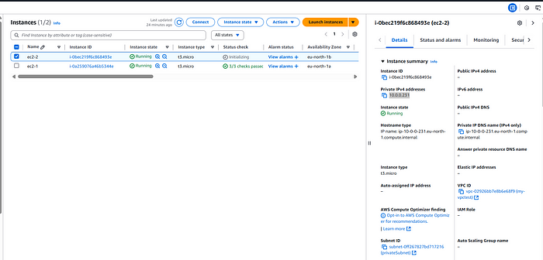

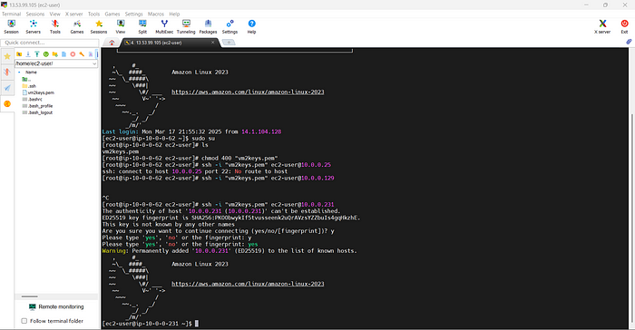

Now, you are inside the Private EC2 Instance!

Finally now we can access private virtual machine inside the private subnet.

so boiston refer to my public ec2 isntace

###### ChatGPT said:

Yes, exactly!

A **Bastion Host** refers to a **public EC2 instance** that serves as a gateway for accessing EC2 instances in a **private subnet**. Since the private instance doesn't have a public IP, you can't SSH directly into it from the internet. Instead, you SSH into the **Bastion Host** first (which has a public IP) and then access the private instance from there.

### Key Points:

* **Bastion Host**: A **public EC2 instance** with a public IP that you use to access the private subnet.
* **Private Instance**: An EC2 instance in a **private subnet** that doesn't have direct internet access (no public IP).

### Flow:

1. **SSH into Bastion Host (public EC2)** using its public IP.
2. **From Bastion Host**, SSH into the private instance using the private IP of the private instance.

after ssh into one instance and then again we neeed to run ssh commands - show me exampple of cmd how to run

###### ChatGPT said:

When you're SSH'd into the **Bastion Host** (public EC2 instance), and you want to SSH into the **private EC2 instance**, you'll follow these steps. After you SSH into the Bastion Host, you'll run the SSH command from the Bastion Host to access the private instance.

### Example:

1. **Step 1: SSH into the Bastion Host (Public EC2 Instance)**:
   * From your local machine, use the following command to SSH into the Bastion Host (public EC2 instance):

bash

CopyEdit

ssh -i /path/to/your/bastion-key.pem ec2-user@bastion-public-ip

* + Replace /path/to/your/bastion-key.pem with the path to your **Bastion Host private key** and bastion-public-ip with the **public IP** of the Bastion Host.

1. **Step 2: SSH into the Private EC2 Instance**:
   * Once you are logged into the Bastion Host, SSH into the **Private EC2 instance** using its **private IP**:

bash

CopyEdit

ssh -i /path/to/your/private-instance-key.pem ec2-user@private-instance-private-ip

* + Replace /path/to/your/private-instance-key.pem with the **private key** for the private EC2 instance and private-instance-private-ip with the **private IP** of your private EC2 instance.

### Full Example:

* **SSH into Bastion Host**:

bash

CopyEdit

ssh -i /path/to/your/bastion-key.pem ec2-user@34.123.45.67

Where 34.123.45.67 is the **public IP** of the Bastion Host.

* **SSH from Bastion Host to Private Instance**: Once you're logged into the Bastion Host, run:

bash

CopyEdit

ssh -i /path/to/your/private-instance-key.pem ec2-user@10.0.1.25

Where 10.0.1.25 is the **private IP** of the private EC2 instance.

### Summary:

* **SSH from your local machine to Bastion Host**.
* **From Bastion Host, SSH into the private instance** using the private IP.

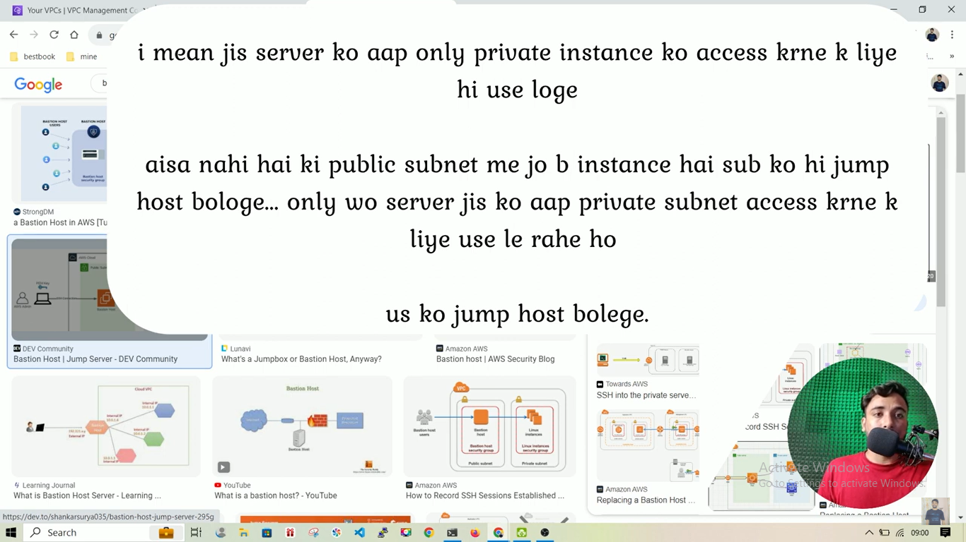

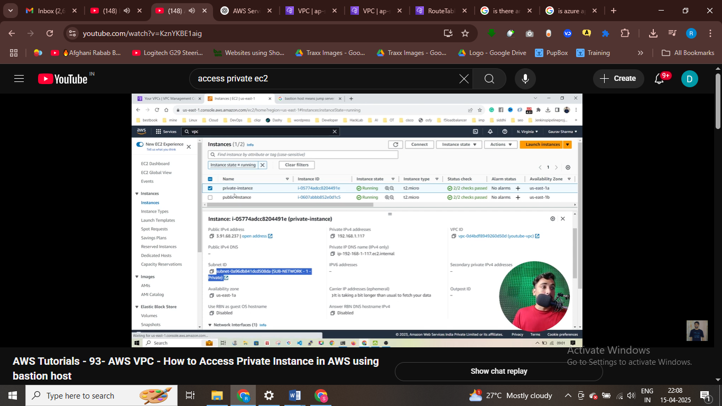

Accessing it to public IP

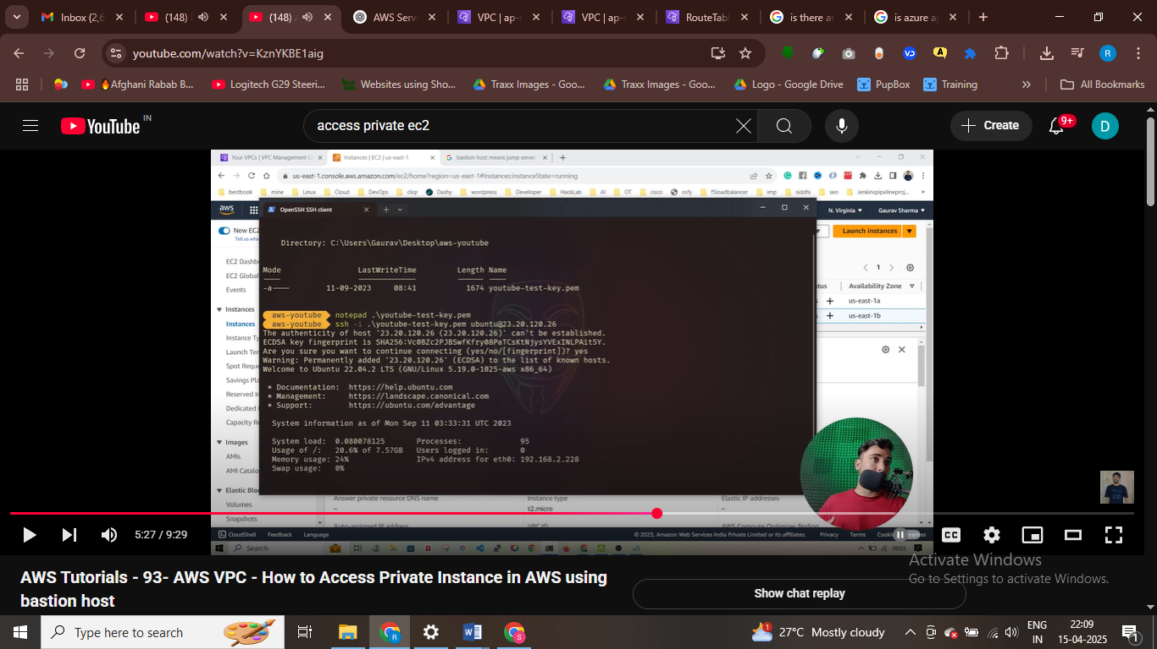

Write now we are at bostion host at jump server

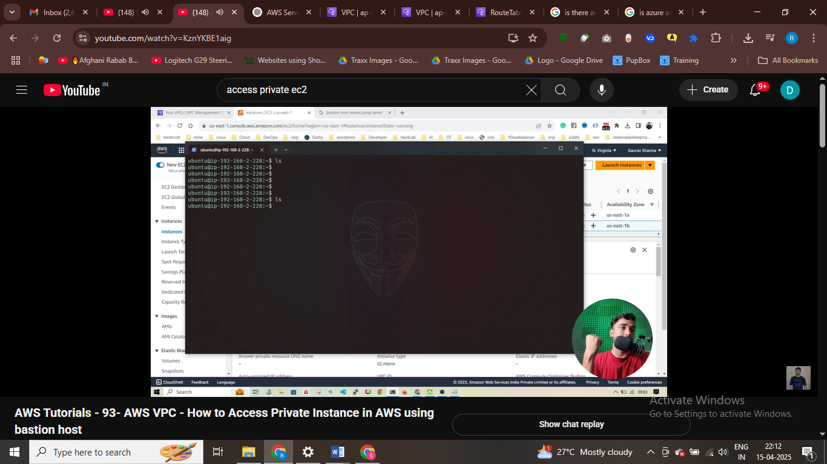

Take content of private key using notepad

And create vi

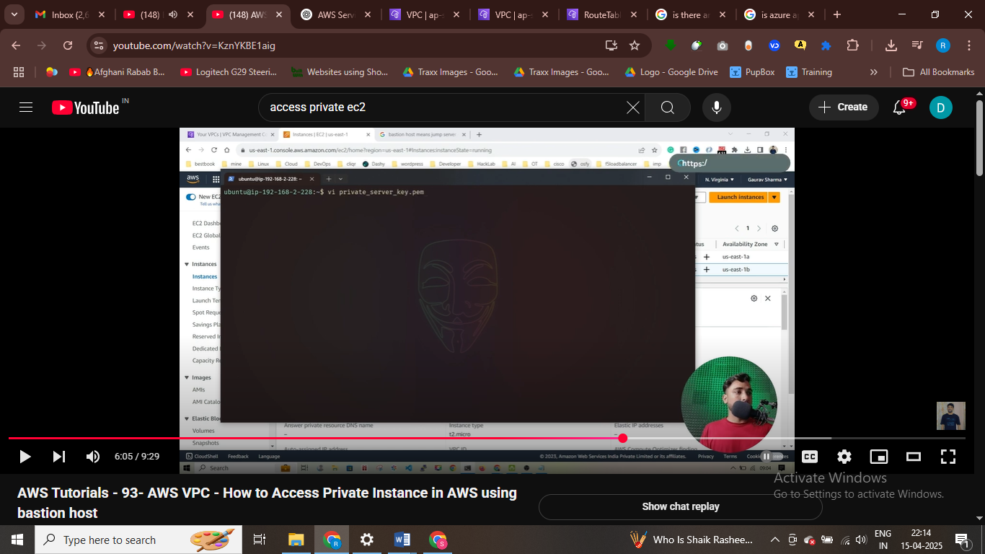

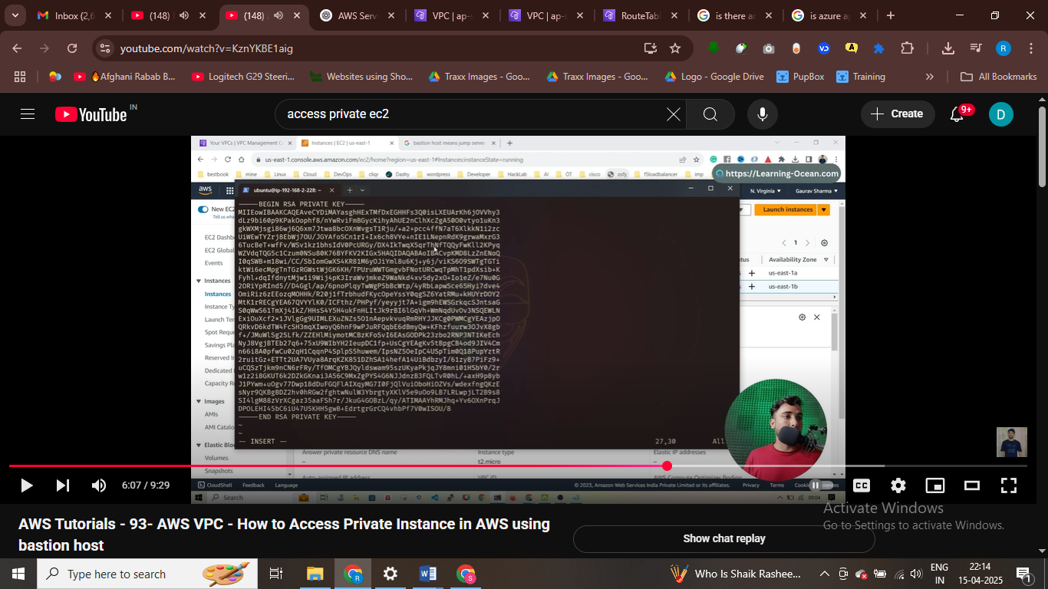

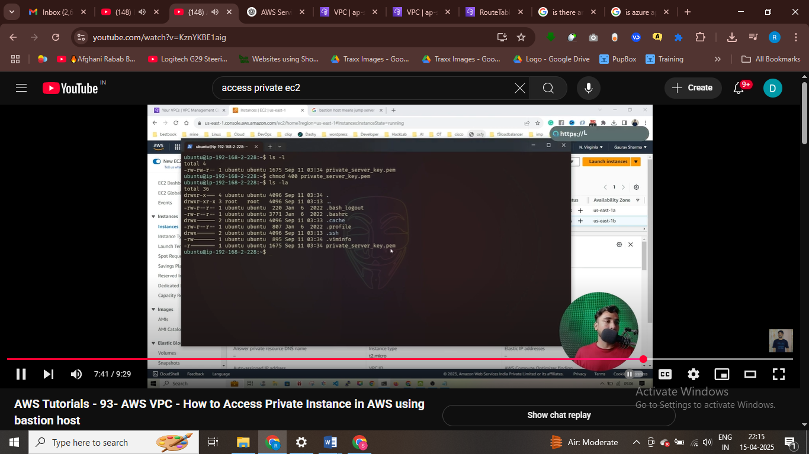

Ssh instance using private ip of isntnace

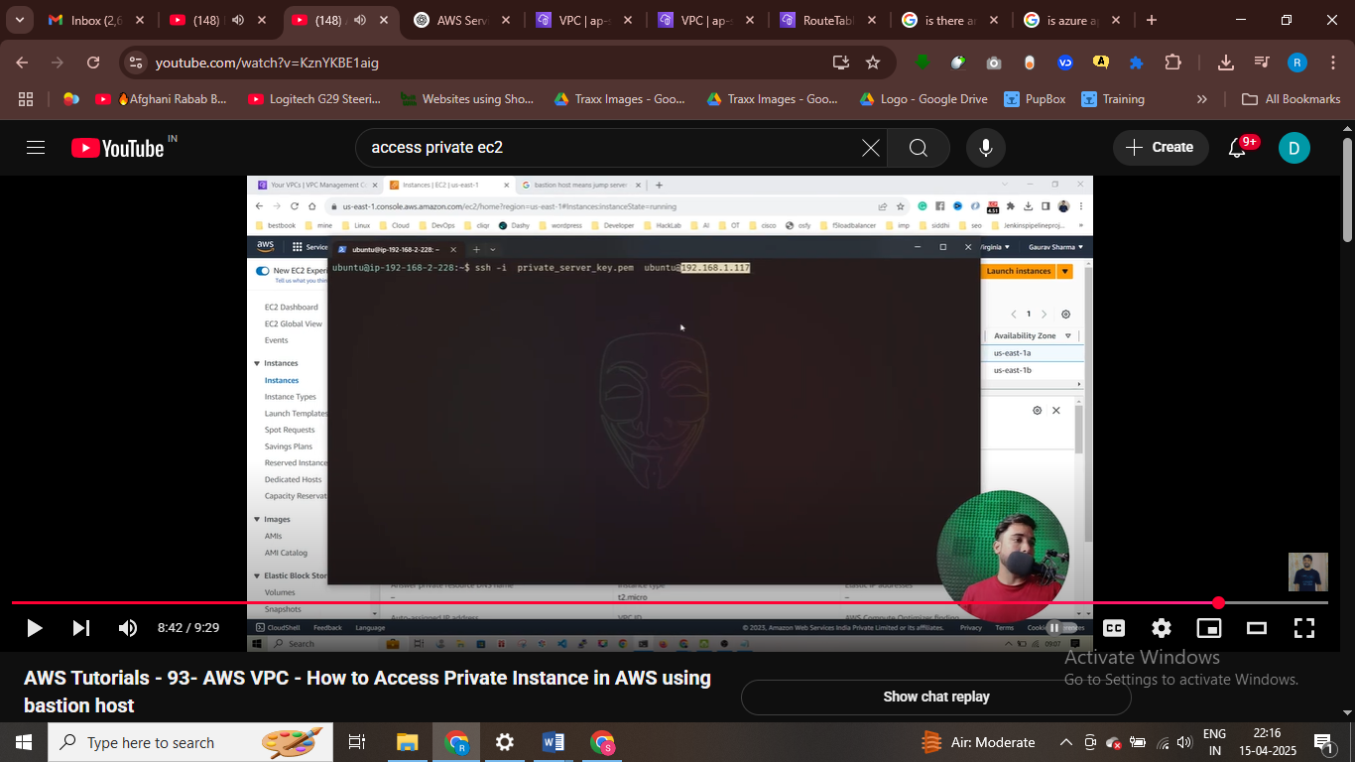

Accessing private instance

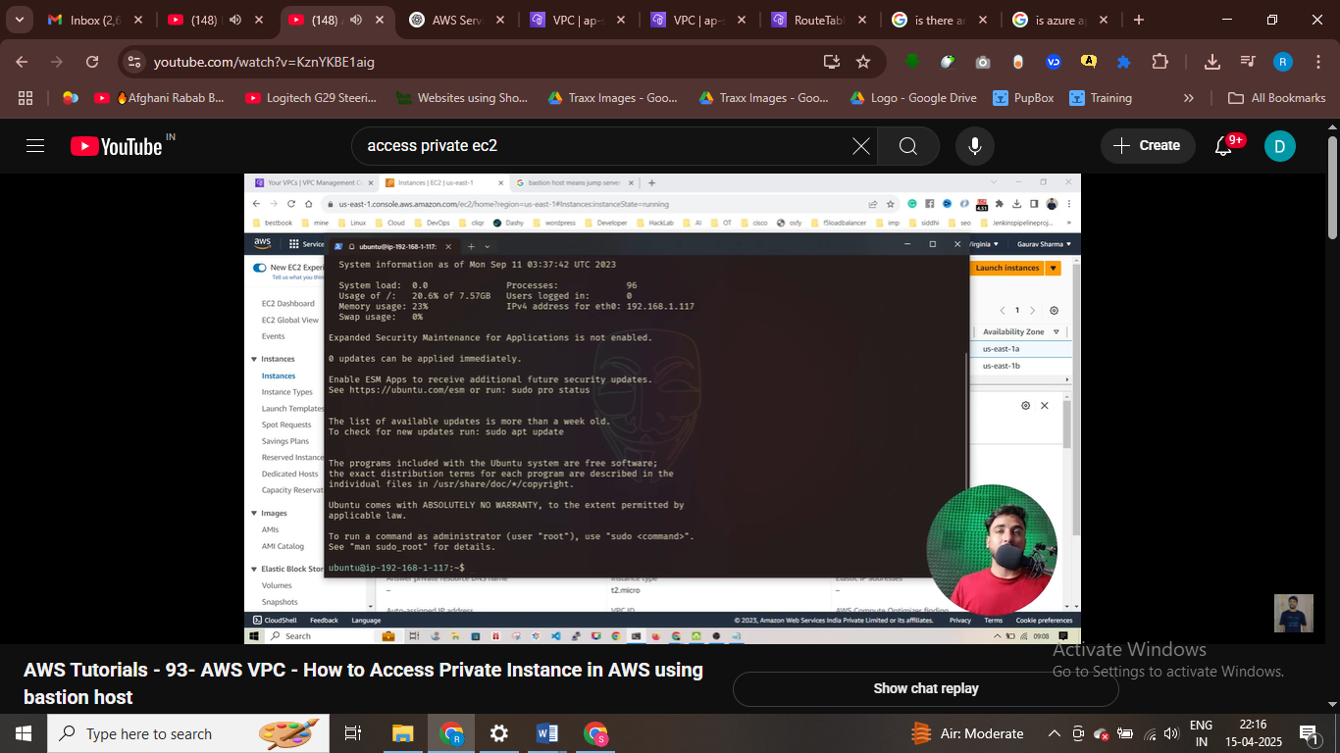

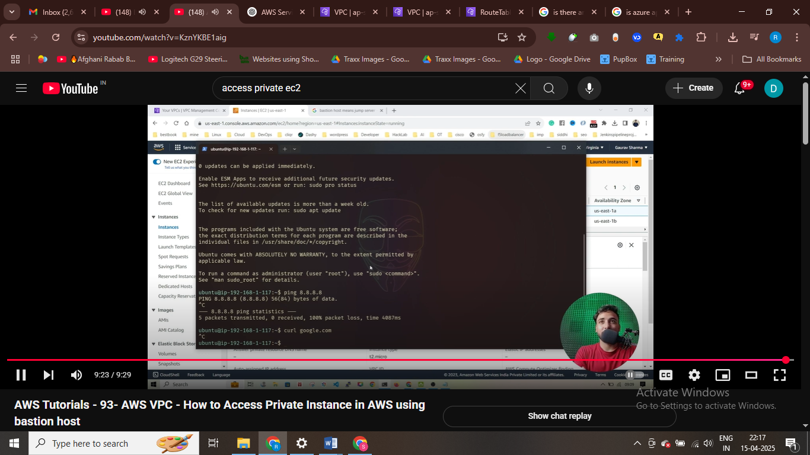

#intenret now working in private instance

Use nat instace

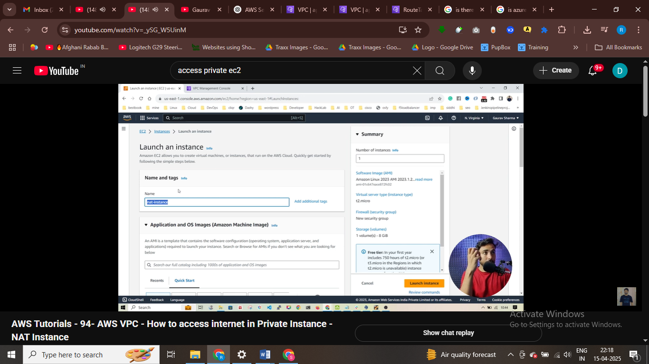

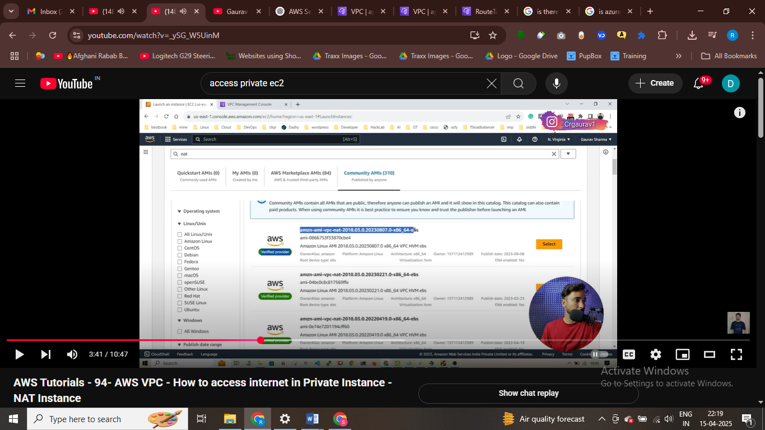

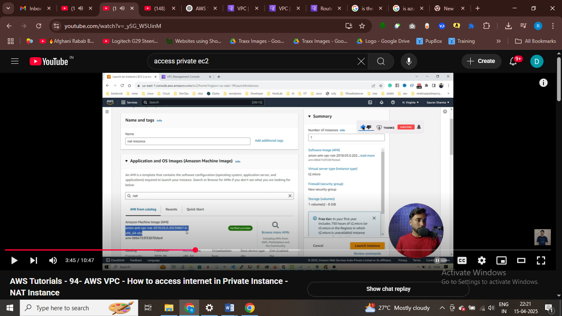

Private ip send traffic to this instace we are using that ami

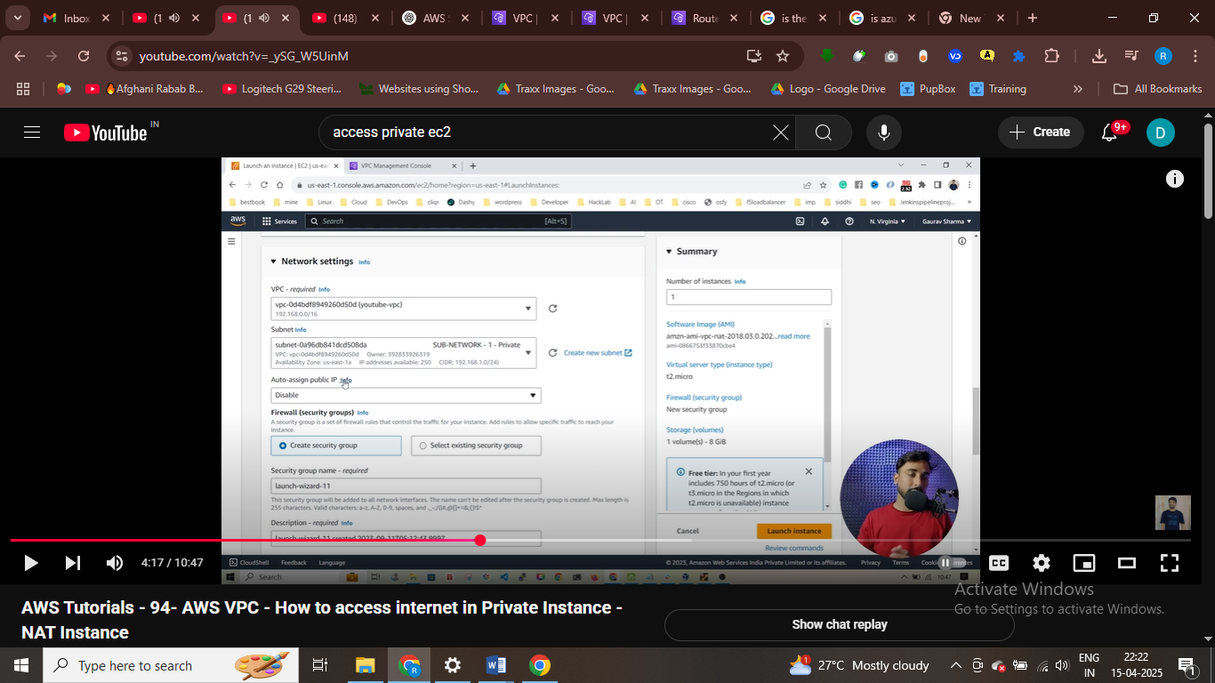

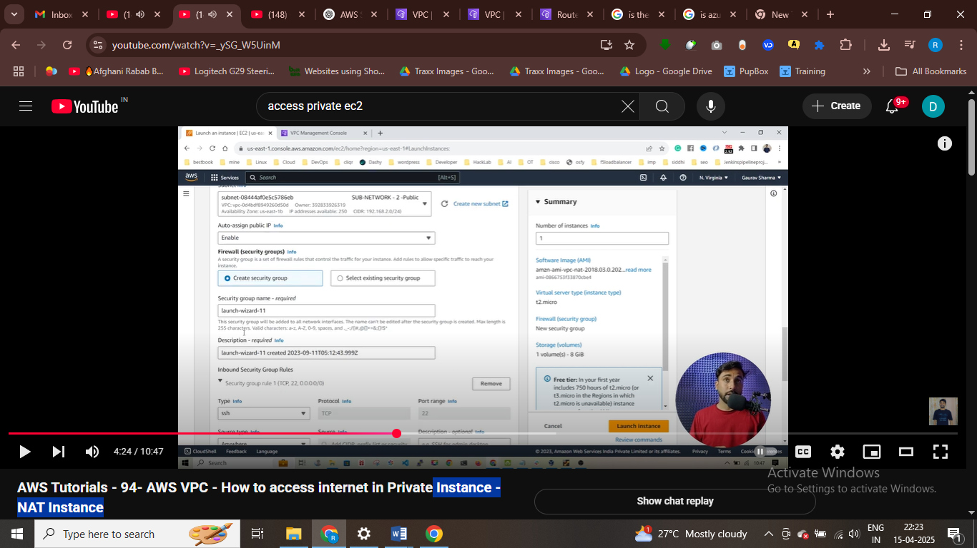

Attaching a elastic ip to nat instance

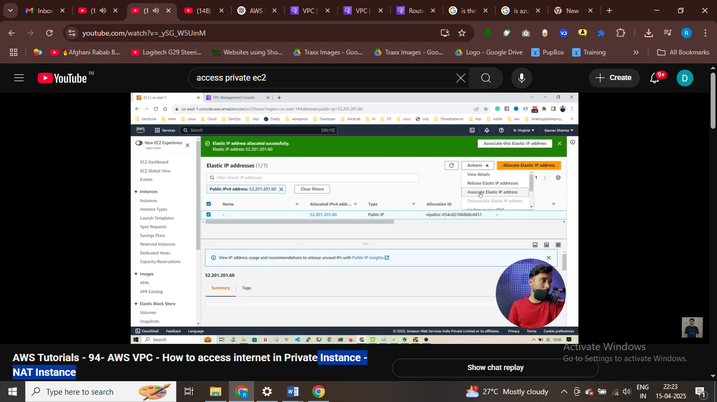

After that associate instace

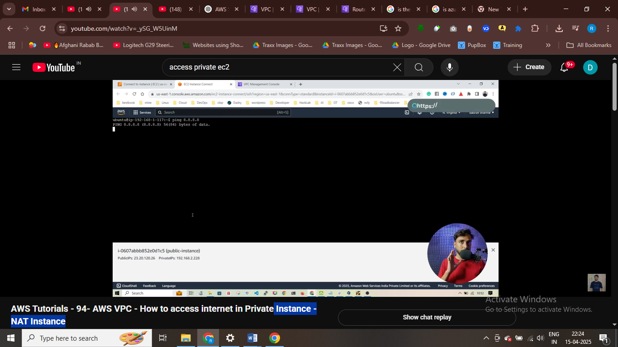

Use route table to see instance private or public

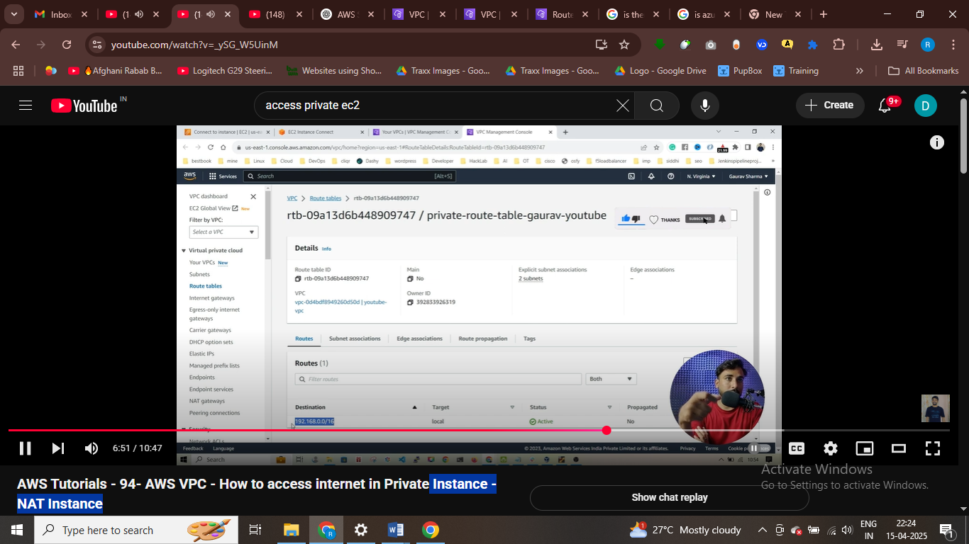

Iss ciddr ka package rha toh who usse locally rahkhenga – usse bhahr nahi bhejgaa

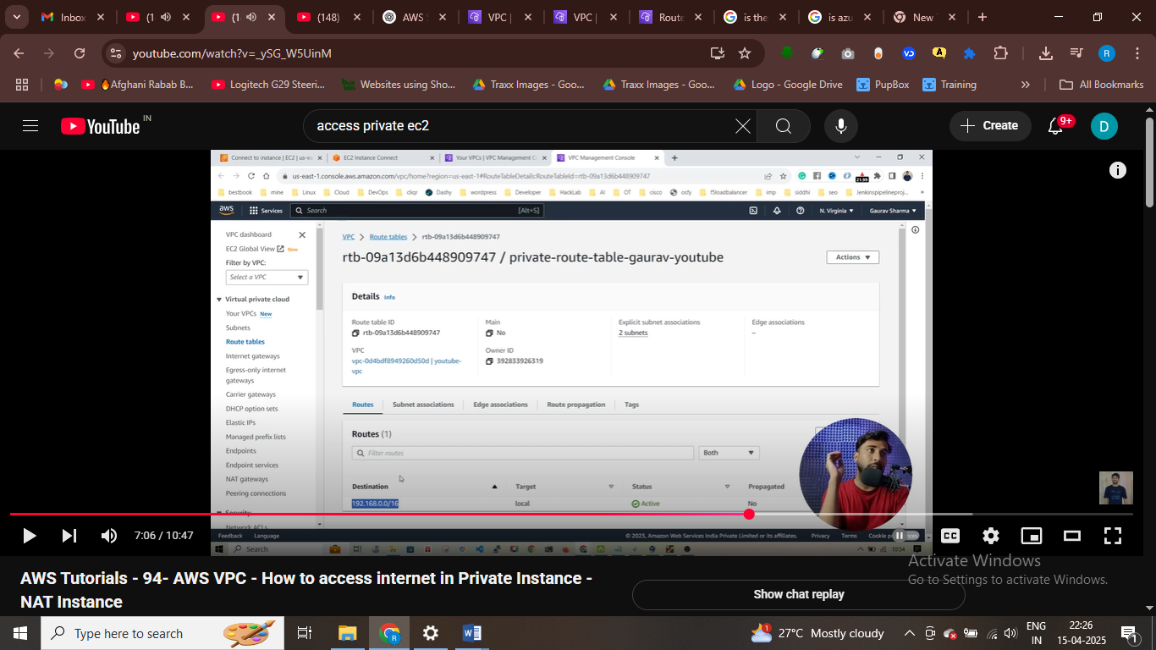

Koi bhi aise package jiska packet iss destiantion pa aaya 0000 toh usse isntacen – nat instance pa bhej rha ha

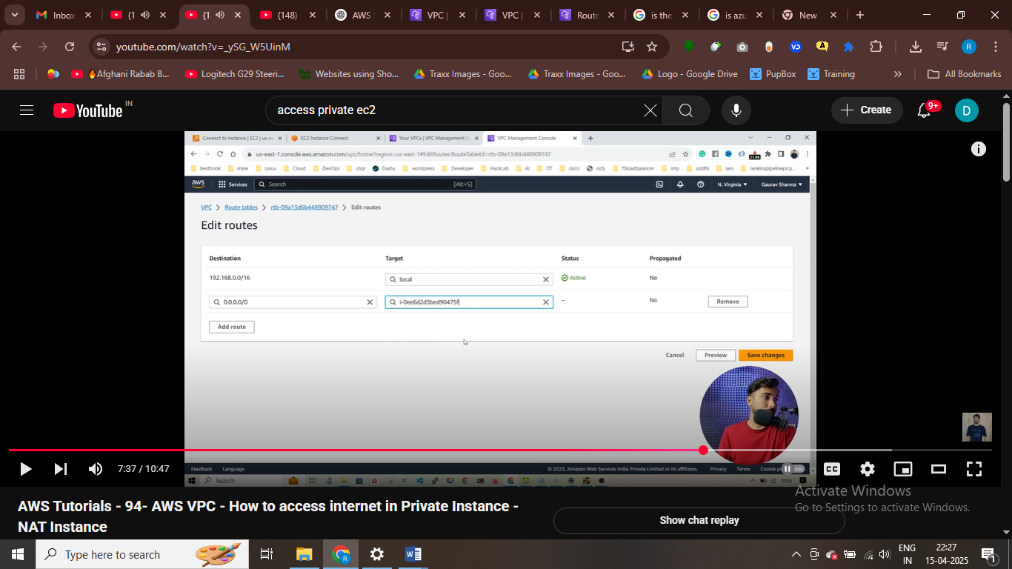

Priavt e instace sent reques to nat isntacne and nat instance send repsoense to private instance and in this we get intenrnet

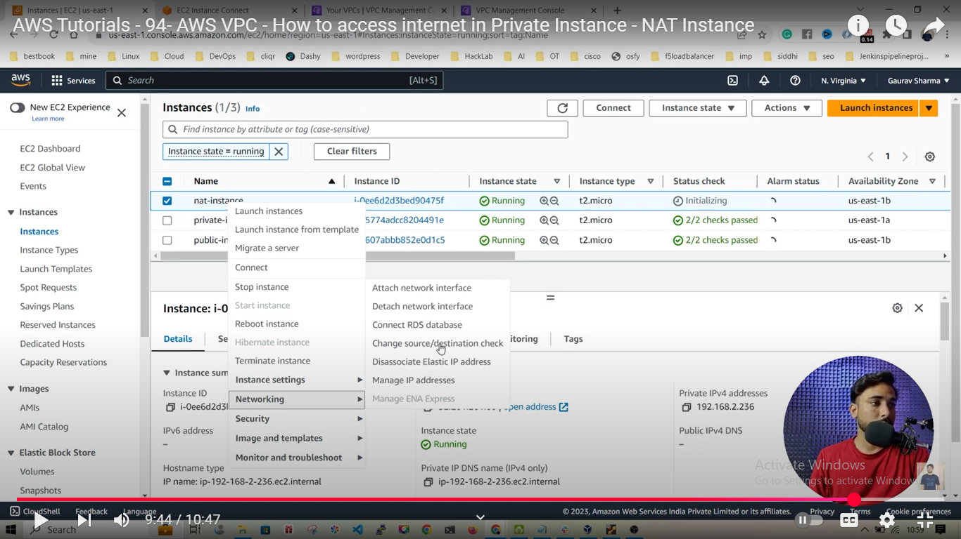

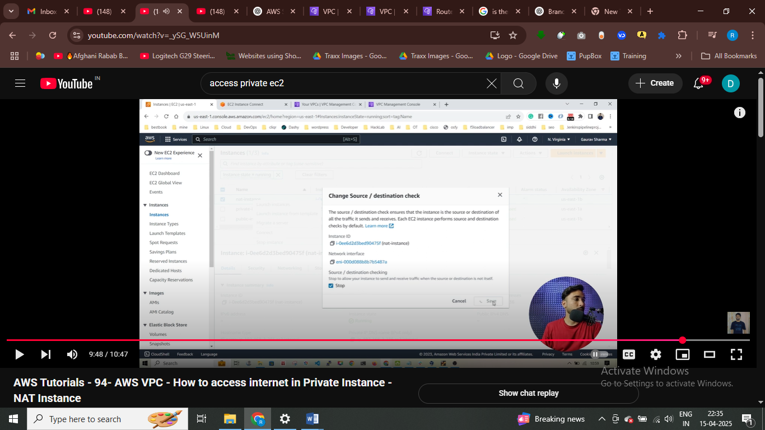

Now internet accessible in this private instance

